5a. MASKING AND SETTING OF LOWER NIBBLES ON GIVEN DATA

AIM:
To write and execute an assembly language program for performing Masking, Setting, One’s and Two’s Complement of given data of 8-bit numbers using 8085 Microprocessor.

APPARATUS REQUIRED:
8085 microprocessor kit 1
Power card 1
Keyboard 1

MASKING OF BITS ALGORITHM:
- Load the Data in A-register.
- Logically AND the content of A with 0FH.
- Store the result in memory location.
- Stop the program

PROGRAM:
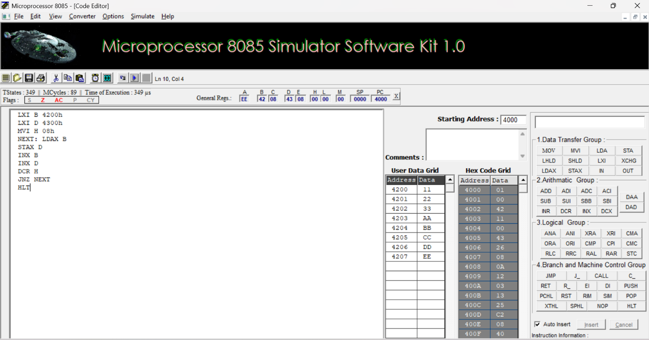

SETTING OF BITS ALGORITHM:
  - Load the Data in A-register.
  - Logically ORI the content of A with 0FH..
  - Store the result in memory location.
  - Stop the program

Output:

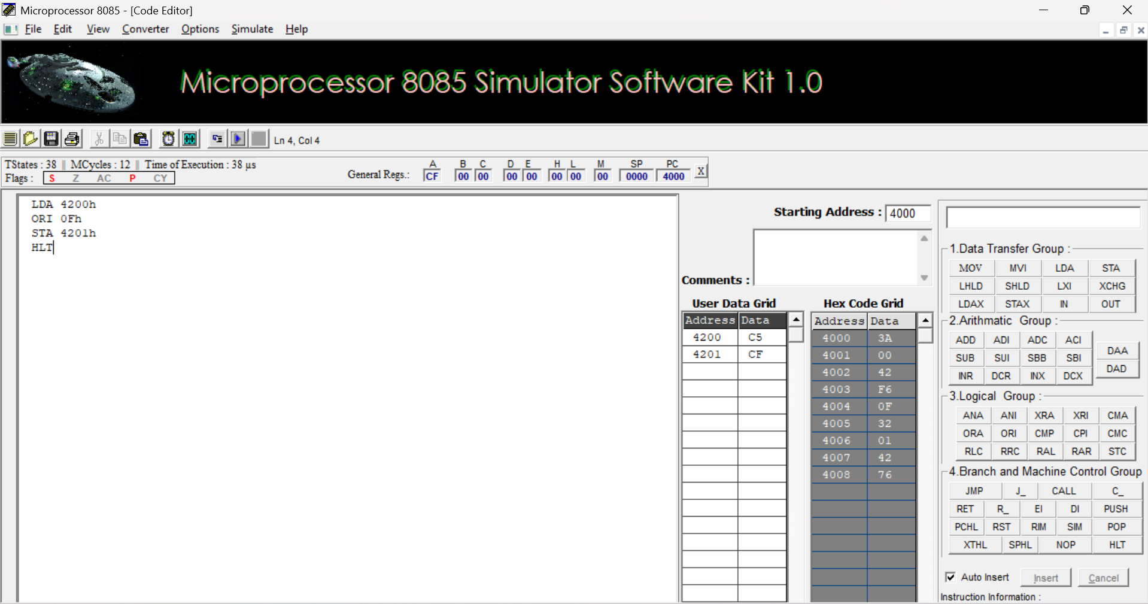

RESULT:
Thus, an assembly language program for performing logical Masking and Setting of bits were executed using 8085 kits.

